Name
Course
Professor’s Name
Date

Western versus Eastern landscape arts and paintings
Abstract
This paper is aimed at comparing the western and eastern landscape arts that existed from the 11th to the 17th century. According to history, the western countries were the European countries and the country far west, America. This paper aims to research the western and eastern landscape paintings and arts so that a comparison; similarities and differences should be known. To mention, pictures in the west and East had characteristics and styles that differed. Nevertheless, many arts were designed and drawn by various artists who were influenced by the landscape they had around them. An example, the painting of arts and scene in China was influenced by the culture of the Chinese, and they had many cultures. The Chinese had different strategies adopted so that they could achieve some ambitions. Seemingly they had passionate painters who were obsessed with their mission of making their traditional culture. Painted art from Tsao family collections included Bada Shanren, rock, and bird. They practiced calligraphy, drew flowers, and birds. Going back to the western landscape arts, there was a variety of landscape arts and artists as well. Western art was prevalent in north and south Europe. The 17th century saw the first exhibition of the European landscape paintings exhibition in Madrid. It was not until the 17th century when landscape painting appeared in Europe at a blow. There were many painters in Rome in this century, and they painted out their landscape concerning their religious backgrounds. This paper will, therefore, talk about the western and eastern paintings and arts, to enable us to understand how techniques were either similar or different in the 11th to 17t century.
Introduction
When studying arts in East and west, we realize that landscape is not only a western idea as people have so far thought it as an artistic theme but also eastern countries such as China, Korea, and Japan. The eastern arts and landscape came earlier than the western. They had cultures and religions that interpreted nature, and hence scene became an independent topo from the beginning of the tenth century. From the Chinese, the nameShanshui or onlyMountains and water in Englishwas esteem for landscape, and it had impressive wonders; hence was declared a painting due to appreciations it had for respecting nature (Pereira, 266-270).
Claude Gelle, later known as Claude Le Lorrain, was a French artist who later on spent his lifetime in Italy as an artist. Claude had a unique style of arts and landscape in his time. In America, we have Freer and Sackler's art gallery in Washington’s National Mall. These two have one of the most important and most critical Asian arts in the world that contains more than 40,000 objects dating from the time of the Neolithic period to date. Elsewhere in the Netherlands, the 1600 landscape paintings boomed in the Dutch Republic and Spanish Netherlands, currently known as Belgium. In Flanders, a province in Spanish Netherlands, the landscape was popularly used by painters more so draftsmen and printmakers from 1500 onwards. Also, Italy had a great neoclassical sculptor called Antonio Canova. He, along with Jacques Louis David, was given a trust of confidence after they ushered the aesthetic of clear and regularized form and calm repose.

Landscape arts in the East and west
Paintings flourished in the Netherlands, Belgium, and Spain. Flanders province had a fashionable taste of painting landscapes, and this was done explicitly by draftsmen and printmakers. Paintings of Pieter Brueghel the Elder paintings such as the harvester was seen at this period from 1525 to 1569. Also, Imagery panoramas done by Joachim Patinir influenced many printmakers, among them (Hans Bol, 1534-1593). Hans, later on, spread ideas of woodcutting, etching, and engravings for his landscape subjects. Many other artists contributed to western landscape art such as Annibale Carracci and Peter Paul Reubens. Paintings in Nothern Europe were Genre scenes that depicted daily life. Their pictures had hidden meanings and had a religious message.
Pieter Aertsen painted an example, Butcher's Stall, in the year 1551. This painting is misinterpret as a basic scene of butchers stall, but inwardly it was Joseph and Mary with baby Jesus on a donkey and giving money to beggars
The popularity of symbolic genres took to apex in the 6thcentury but later on was rivaled by a new art of printmaking. It was rarely appreciated outside northern Europe, where it started in the earlier centuries. Atechnique of renaissance to printmaking was first applied by Durer, an artist in the 1500s. His painted art had a realistic fold in the cloth, and the painting had lines recede. It was a pretty relaxed and mind-blowing art.
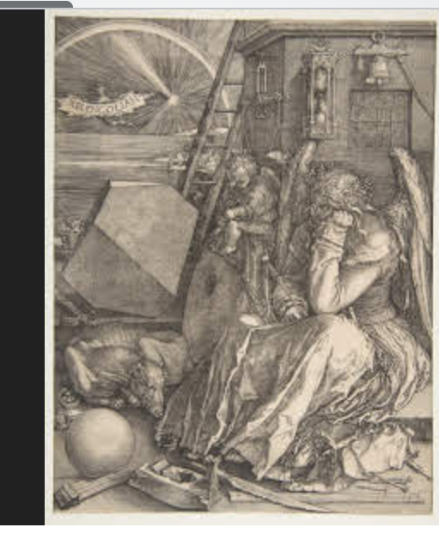
Duer’s painting
In the Eastern world and referring to China specifically, the Ming dynasty fall was a push to creativity for Chinese art. Their paintings were used to create new identities, and this was a means they used to win the negotiations that disrupted and accompanied the fall of the Ming dynasty. An artist inChina and one of the most important in the Ming Dynasty was Dong Quichang, who painted the first section of the exhibition. He also had his calligraphies celebrated all over the country.
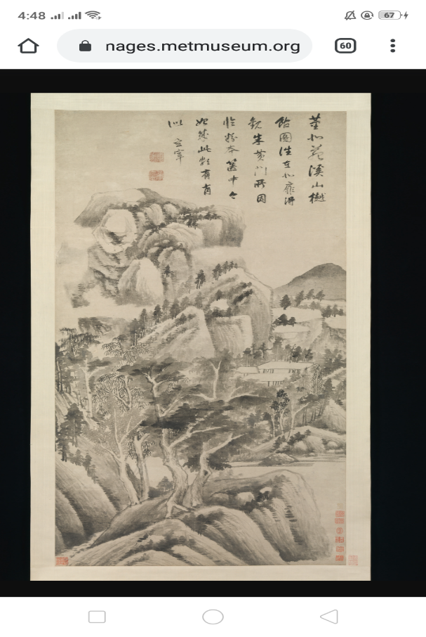

The use of restricted pallete characterized the Dutch paintings and arts dating back to 1630 and 1636. This helped them to depict the unprepossessing tract of lands such as river scenes and dune landscapes. Coastal paintings had dunes and scarce negotiations with scattered human settlements.
Landscape paintings in china were china's significant contributions to arts. History measured it as the late accomplishment of Chinese literature and calligraphy. A writer in 1167 claimed that painting meant nothing less than culture perfection. Seven hundred eighty years later, his claim was validated by an American scholar George Rowley. Fan K'uan did a famous work Travelers among streams and mountains, and it dated back 1000AD had a majestic conception and rationally mountain image. Also, an art of forest scene done by Li Ch'eng shows how Chinese painters were concerned with the matter of life in nature (Pereira, 263-266).
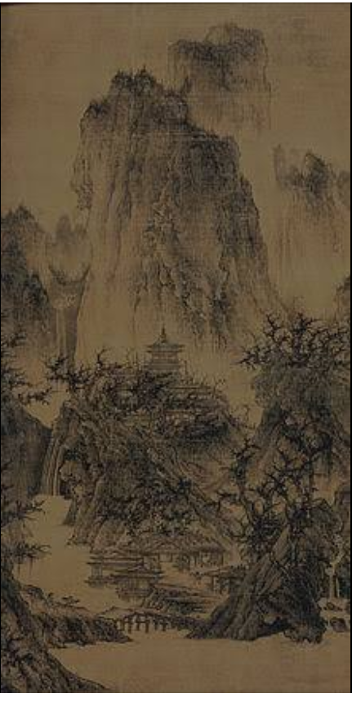
Li Ch’eng’s forest art
The 15th and 16th centuries saw an artistic explosion in china. Beijing in the North and major cities in the lower china Yangzi River become an essential new center that painting operates. The Ming dynasty had political stability, and it flourished economically. This prosperity increased the popularity of art paintings, and sure enough, this delighted the eyes and heart. They painted on silk, and the use of expensive pigments reappeared on the palettes.
Conclusion
The concept is a complex topic since antiquity and this right as we trace the two cultures. Western and eastern artists sensually tried to use geometric and metaphorical perspectives to represent the visual world. Chinese painters, unlike Western painters who attempted to create an exact environment view, never had a notion of space as a measurable geometric entity. They did not develop mathematical rules for organizing the area, and neither did they create clear spatial relations. Chinese instead had an outlook that emphasized a dynamic structure.

References
Adams, Ann Jensen. "Competing communities in the great Bog of Europe': identity and seventeenth-century Dutch landscape painting." Landscape and power, Chicago (1994).
Doering, Zahava D., and Adam Bickford. "Visitors to the Smithsonian Institution: A summary of studies." (1997).https://repository.si.edu/bitstream/handle/10088/17208/opanda_97-3-SIVisitors.pdf
Kahr, Madlyn Millner. Dutch painting in the seventeenth century. Routledge, 2018.https://books.google.co.ke/books?hl=en&lr=&id=jtnQ7PIT8mcC&oi=fnd&pg=PR6&dq=Met+Museum:+Landscape+Painting+in+the+Netherlands&ots=GYQspqv_m5&sig=RukQ6IlB_FCcxP_zZMclg2EWJC8&redir_esc=y#v=onepage&q=Met%20Museum%3A%20Landscape%20Painting%20in%20the%20Netherlands&f=false
Murray, Linda. The high renaissance and mannerism. Thames and Hudson, 1967.http://llrc.mcast.edu.mt/digitalversion/Table_of_Contents_26792.pdf
Pereira‐Pardo, Lucía, et al. "Multi‐analytical approach to the material characterization of 16th-century wall paintings from R Ribeira Sacra (G Alicia, NW S pain): Pictorial palette, technique, and alterations." Color Research & Application 41.3 (2016): 263-269.
Sorabella, Jean. "The Nude in the Middle Ages and the Renaissance." Heilbrunn Timeline of Art History (2011).https://www.metmuseum.org/toah/hd/numr/hd_numr.htm

